Procedure Number:  PRD-MOS-HUE-448 | Procedure Name: Honeywell User Experience (HUE) | Effective Date: 14-May-2017
Procedure Owner:  Tobias Komischke | Process Name:  IT Management Operating System | Revision Date: 14-May-2018

Purpose

This procedure provides the overview of HUE activities that have to be carried out in project-related IT waterfall and agile processes which result in offerings that are directly impacting users*. If the offerings are not user-facing, these HUE activities are not required.
* A user is anybody internal to HON or external (customers, partners, etc.) who utilizes or consumes the IT system or service that the project is creating or enhancing.

Expected benefits from incorporating HUE include:
- Higher operational effectiveness:
  - Better project planning and execution; less UI rework late in the process
- Better user experience of systems and services. In terms of bi-modal IT:
  - Top-line improvements: more differentiated offerings, expanded market share, customer loyalty, premium pricing
  - Bottom-line improvements: higher productivity, lower maintenance cost, lower training cost

Scope
This procedure is for planning and executing HUE activities in project-related IT waterfall and agile processes.

Project types are:
- New Capabilities
  - A new capability is any product adding or replacing a platform, application, or new technology increasing software or hardware capabilities and thereby creating business value.
- Enhancement
  - An enhancement is any product change or upgrade that increases existing software or hardware functionality beyond original client specifications. In general, product enhancements include:
    - Additional functionality
    - Greater processing speed
    - Better cross-platform compatibility
- Maintenance/Admin
  - The modification of a product (software or hardware) to correct faults, and/or maintain performance and robustness.
- Process
  - Business process designed to drive effectiveness and efficiency in meeting business goals.
- Discovery/Pilots
  - New discoveries & innovation, proof of concept, or pilots
- Mergers & Acquisitions (M&A)
  - Integration/Divestiture/or Roof Top Consolidation of an Acquired Company’s IT assets.

Obligations
All artifacts created by this procedure must be stored in a location accessible by all stakeholders for a minimum of one year or longer, if applicable, according to the Honeywell Records Retention Schedule. [PRD-MOS-HUE-010]

Procedure Activities

Mapping of HUE Process to IT Waterfall process

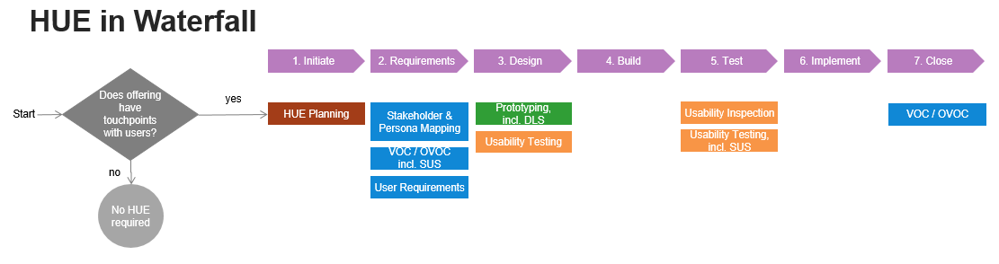

Mapping of HUE Process to IT Agile process

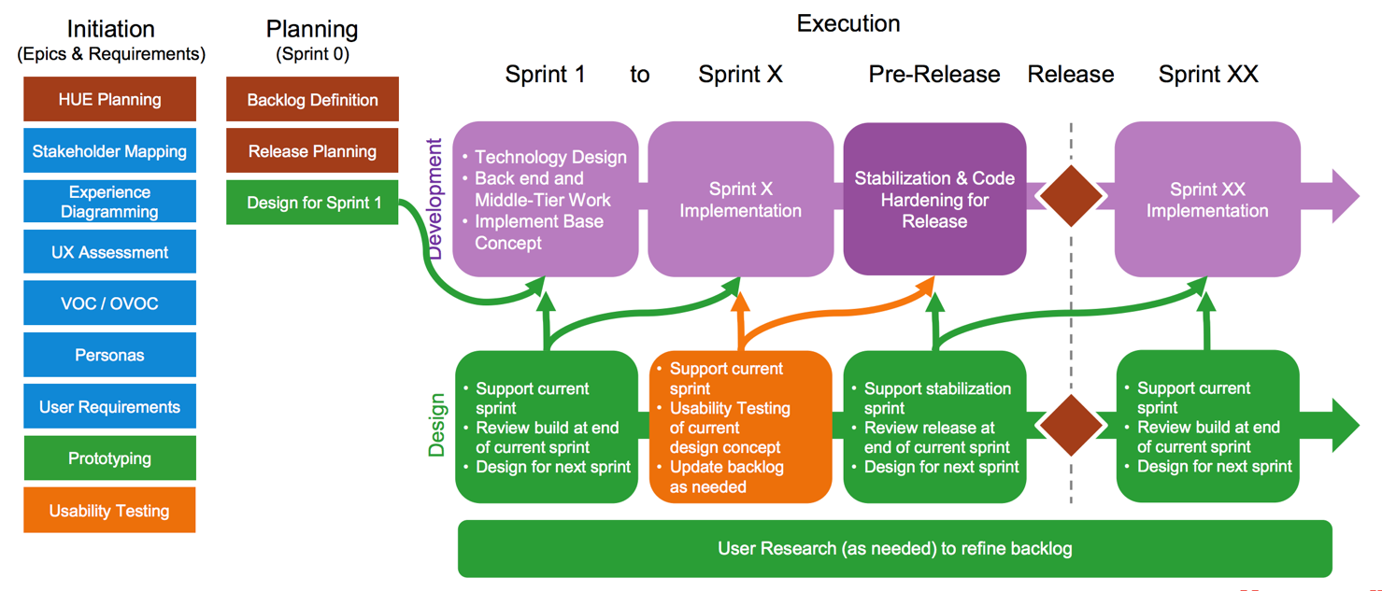

Mapping of HUE Process for COTS (Commercial Off the Shelve) offerings

Mapping of HUE Process for all other project management process

We strongly recommend that any project must allocate time to understand the user’s needs, iterate on possible solutions and validate the solution with the users before it is build and deployed. The building blocks remains the same although depending on the available knowledge and time, project team members can decide which tools to pick for the project. The mandatory block is Usability Testing.

Name of Procedure Step | Role(s) – (Who) | Description– (How To)
HUE Planning (mandatory) | HUE Representative, Project Manager,  Project Sponsor | Review project needs and identify the scope for HUE activities required. [PRD-MOS-HUE-020]  Applicable work instruction:  - “HUE Planning”
Stakeholder & Persona Mapping  (mandatory) | HUE Representative, Project Manager, Subject Matter Experts | Identify and prioritize those roles who have a stake in or are affected by the solution; document their key characteristics, pain points and needs. [PRD-MOS-HUE-030]  Applicable work instruction:  - “Stakeholder Mapping”  - “Personas”
VOC/OVOC  (mandatory) | HUE Representative | Understand user needs and characteristics first hand. [PRD-MOS-HUE-040]  Applicable work instructions:  - “Interviews” and/or  - “Field Observations” and/or  - “Surveys”
User Requirements (mandatory) | HUE Representative | Formulate evidence-based target characteristics and abilities of the solution that are important for its users in terms of usefulness, usability and desirability. [PRD-MOS-HUE-050]  Applicable work instructions:  - “User Requirements”
Prototyping  (mandatory) | HUE Representative | Create draft versions of the offering, allowing users to explore intent behind a feature or the overall design before it is developed. The Honeywell Design Language System (DLS) has to be followed. [PRD-MOS-HUE-060]  Applicable work instruction:  - “Prototyping”
Usability Testing  (mandatory) | HUE Representative, Project Manager | Empirically identify UX strengths and weaknesses of a product and derive options for optimization. [PRD-MOS-HUE-070]  Applicable work instruction:  - “Usability Testing”
Usability Inspection  (mandatory) | HUE Representative | Execute a gap analysis of implementation versus design intent. [PRD-MOS-HUE-080]  Applicable work instruction:  - “Usability Inspection”
System Usability Scale – SUS (mandatory) | HUE Representative | Measure the perceived user-friendliness of an interactive product through a 10-item questionnaire: This is a mandatory sub-step in OVOC/VOC and usability testing activities  - “System Usability Scale”  [PRD-MOS-HUE-090]
In addition to the above steps, there are few additional HUE activities that a project team can use for better understanding, designing and evaluating their solutions
Experience Diagramming (optional) | HUE Representative, Project Manager, Subject Matter Experts | Understand and document the stages and touchpoints a user encounters in his/her end to end user journey with a Honeywell offering. [PRD-MOS-HUE-100] This tool is applicable for redesign projects  Applicable work instruction:  - “Experience Diagramming”
UX Assessment (optional) | HUE Representative, Project Manager | Identify the current level of user experience of an offering. [PRD-MOS-HUE-110] This tool is applicable for redesign projects  Applicable work instructions:  - “Heuristic Evaluation” and/or  - “Usability Testing” and/or  - “Competitive Analysis”
Concept Ideation (optional) | HUE Representative, Project Team, Subject Matter Experts | Explore design options and involve stakeholders to review and select the design direction that will be taken forward. [PRD-MOS-HUE-120]. This tool is applicable for new projects which does not have a legacy system to refer to.  Applicable work instruction:  - “Concept Ideation”

Outcomes
The outcomes depend on the HUE needs of the project (refer to Work Instruction “Planning”). For every identified and agreed upon HUE activity the corresponding artefact needs to be created, reviewed and approved by the project sponsor and/or audit team.

Roles and Responsibilities

Role | Responsibilities
HUE Representative | Plan, carry out HUE activities in project; document and store results on project share drive
Project Manager | Plan HUE activities; identify and recruit subject matter experts, stakeholders and usability test participants
Project Sponsor | Defines goals and objectives of the project, funds the project
Subject Matter Experts | Participate in Stakeholder Analysis
Project Team | Participate in Concept Ideation sessions

RACI

R=Responsible, A=Accountable, C=Consult, I=Informed

Procedure Step | HUE Representative | Project Team | Project Manager | Subject Matter Experts | Project Sponsor
Planning | R |  | R/A | C | I
Stakeholder Mapping | R/A |  | R | C
Experience Diagramming | R/A |  | I | C
UX Assessment | R/A |  | C | C
VOC/OVOC | R/A |  | C | C
Personas & Scenarios | R/A |  | I | C
Concept Ideation | R/A | R | I | C
Prototyping | R/A |  | I | C
Usability Testing | R/A |  | C | C
Usability Inspection | R/A |  | I | I

Measurements

Procedure KPIs: http://go.honeywell.com/ITKPIs
- KPI name: System Usability Scale (SUS) Score, see Work Instruction “System Usability Scale”. The SUS provides an answer to the question whether following the IT MOS process and this procedure yields the intended results - which is highly usable offerings.
- KPI range: 0 - 100
- KPI target value: 68 or higher

Enforcement

Failure to adhere to published policies, processes, procedures, work instructions and standards will be evaluated on a case by case basis and may result in disciplinary action. Published policies, processes, procedures, work instructions and standards are also subject to audit by Honeywell Corporate Audit and external auditors for verification of compliance.

Version Control and Review Frequency

This Procedure is to be reviewed at minimum annually.

Date Last Reviewed: 27-Feb-2018
Reviewed By: Tobias Komischke, IT HUE Leader

Version # | Effective Date | Section(s) | Description | Author | Content/SME  Approval | Procedure Owner Approval
V1 | 20-Mar-2017 | All | First draft | Tobias Komischke | Madhumita Gupta | Tobias Komischke
V1.1 | 25-Aug-2017 | “Scope” Section | Incorporated new project type definitions | Tobias Komischke | Madhumita Gupta | Tobias Komischke
V2 | 01-Nov-2017 | All | Incorporated new role of HUE representative and aligned to approved HUE process integration with waterfall/agile Software process | Madhumita Gupta | Tobias Komischke | Tobias Komischke
V2.1 | 27-Feb-2017 | All | Formatting edits based on Process Change Register requests | Tobias Komischke | Madhumita Gupta | Tobias Komischke
*Process Owner, Process Governance and External Compliance approvals are through the automated tool

